**Create Calculated Field in Tableau**

Last Updated : 24 May, 2024

In this article we will learn how to create calculated field in tableau worksheet to do further operations. For this first look into these two terms:

* **Tableau:** Tableau is a very powerful data visualization tool that will be employed by data analysts, scientists, statisticians, etc. to see the info and obtain a transparent opinion supported the info analysis. Tableau is extremely famous because it can absorb data and produce the specified data visualization output during a very short time.
* **Field:** A knowledge field may be a place where you’ll store data. Commonly wont to ask a column during a database or a field during a data entry form or web form. The sector may contain data to be entered also as data to be displayed.

For this we have to follow some steps :

Open the Tableau tool and connect a dataset into it. Drag and drop the one sheet of the connected dataset. Click on sheet1 to open the tableau worksheet. On clicking Sheet1 you will get whole dataset attributes on the left side and a worksheet for work.

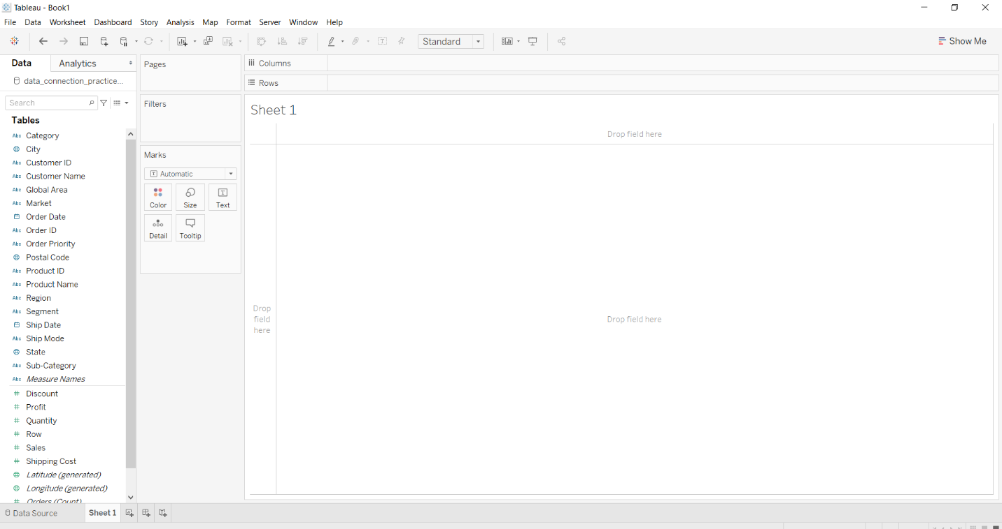

To create a calculated field you have to follow given instructions.

* Go to Analysis or down arrow.
* Click on create calculated field
* Write the field name
* Write the field formula for creation
* Click Apply button.
* You are done and see the data.



**Example 1:**

In this example, we create a calculated field with name Travelling Days form Order data and Ship date fields. Here, we use Datedifference method to subtract dates and calculated the number of days. The result is shown below:



**Example 2:**

In this example, we create a calculated field with name TAddress form City, State, Region and Postal Code fields. Here, we use String Concatenation method and convert the integer postal code into a string. The result is shown below :

